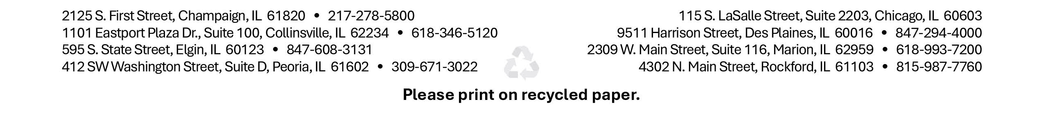
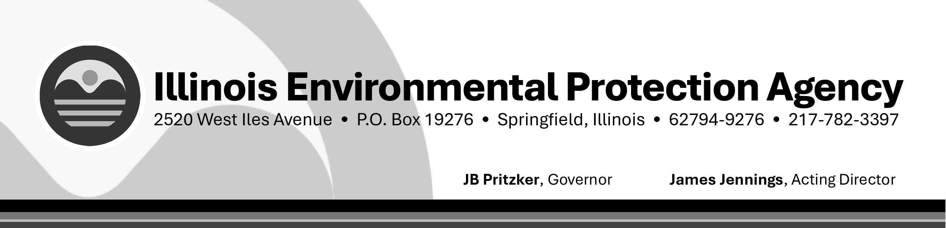

Potential Service Line Containing Lead Notice Certification Form
Please complete this form and return to: Lead/Copper Coordinator, Illinois EPA /BOW/CAS #19, 2520 West Iles Avenue, P.O. Box 19276, Springfield, IL 62794-9276. If you have questions, please call the Lead/Copper Coordinator at 217-785-0561.

PWS Name: PWS No.

Today’s Date:

Notices were provided to consumers by (date):
Please initial each box verifying that the mandatory requirement was completed

The water system also certifies that these notices containing the following information were provided to customers served by a potential lead service line during the reported calendar year:
Explains that the customer is served through a lead, galvanized requiring replacement, or unknown service line where applicable.
An explanation of the health effects of lead
Steps that consumers can take to reduce exposure to lead in drinking water
Contact information for your water utility
Information on service line replacement

DELIVERY METHOD
Please initial each applicable box
The information notice was distributed by the following method(s)
By Direct Mail
By Hand Delivery
By Electronic mail
Other

Signature of Owner, Administrative Contact, or Official Custodian

I, , hereby certify that the potential service line containing lead notice has been provided to each customer that is served through a lead, galvanized requiring replacement, or unknown service line.
Signature Date

Title

